3.4 I can respond appropriately to problems with multiple page web sites.

Here I will be showing my links to each page and how I would fix them if they were broken

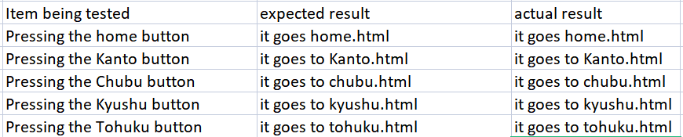

[The above image show an excel table of all the buttons and where they go to]

If the links were broken I would go onto my Visual Studio HTML file and correct the navigation code within that page.

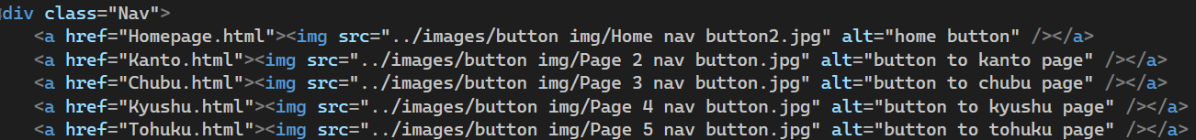

[Above the image shows the code that I use for my web pages]

I would also make sure I am not using an absolute file link for my HTML file links as it wouldn’t work.

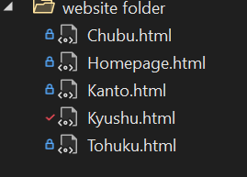

[The above image shows the website folder that my web pages are uploaded from]

I can also right click them to check the file path.

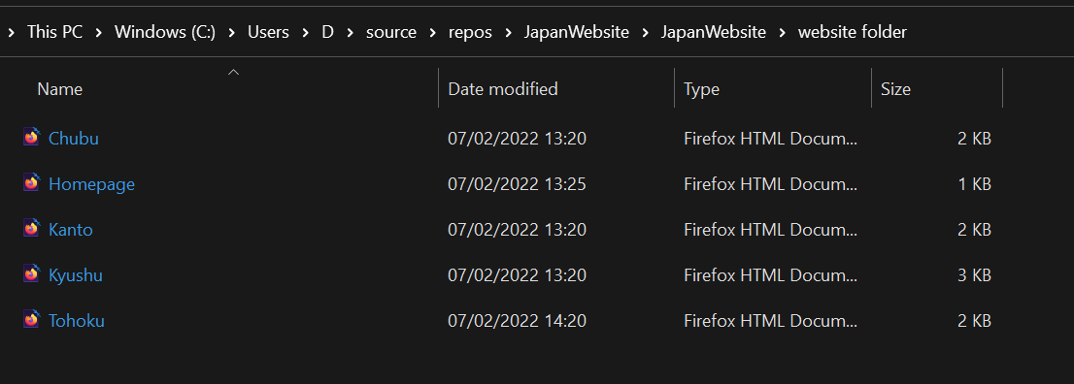

[The image above shows the HTML files on my computer which can be uploaded and downloaded to any computer for use on Visual Studio]